FIGURE 1

Figure 2 – Percent uninsured versus median household income per year (USD).

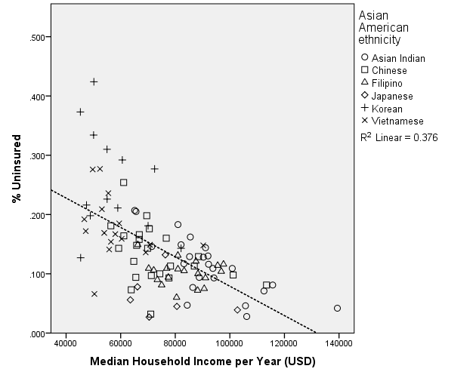
Figure 3 – Percent uninsured versus percent self-employed.
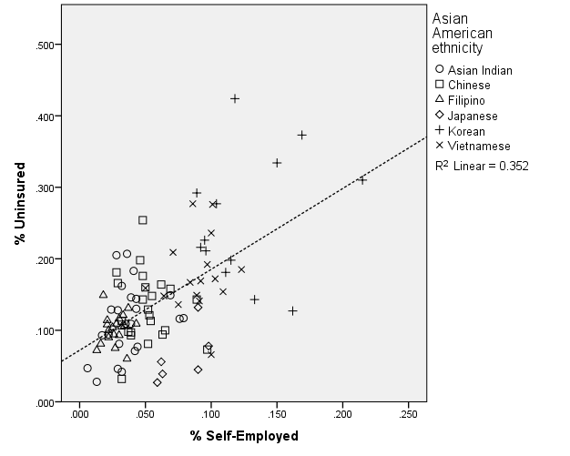
Figure 4 – Percent uninsured versus percent high school graduate or higher.
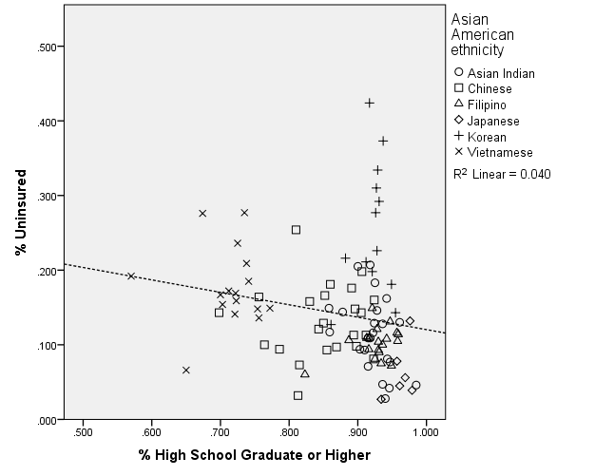
Figure 5 – Percent uninsured versus percent native-born.
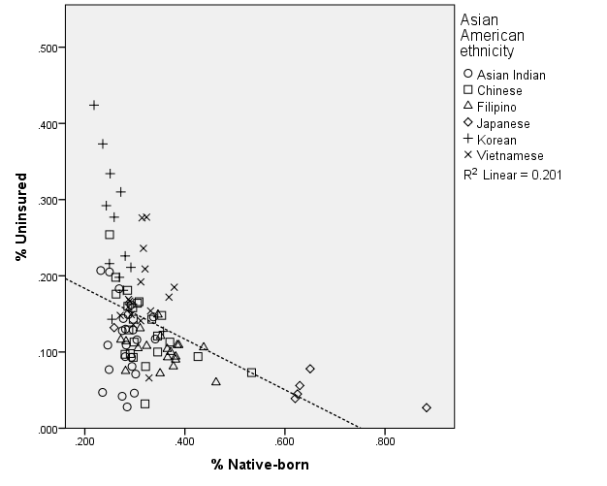
Figure 6 – Percent uninsured versus percent limited English proficient.
